**Title**

Dragos Leordean, Eugen-Richard Ardelean1, *

1Department of Computer Science, Technical University of Cluj-Napoca, Cluj-Napoca, Romania

**\* Corresponding authors:** [ardeleaneugenrichard@gmail.com](mailto:ardeleaneugenrichard@gmail.com)

**ORCID Author IDs:**

Eugen-Richard Ardelean: 0000-0002-0098-4228

Raluca Laura Portase: 0000-0002-8985-4728

**Abstract:**

**Keywords:** yolo, object detection, histology,

# Introduction

## Histology

Pathology diagnosis has been performed by a human pathologist observing the stained specimen on the slide glass using a microscope. In recent years, attempts have been made to capture the entire slide with a scanner and save it as a digital image (whole slide image, WSI) (1).

Manual annotation is time consuming and subject to inter-rater variability (2,3)

Researchers have begun applying deep learning techniques to these databases to automate the analysis of structures from histology slides (2,4–6)

Histopathology Imaging Histopathology is the study of the signs of the disease using the microscopic examination of a biopsy or surgical specimen that is processed and fixed onto glass slides. The images used in this process are called histopathology images. To visualize different components of the tissue under a microscope, the sections are dyed with one or more stains. The histopathology images are used for the diagnosis of different human organs

## Neural networks in medical applications

The applications of deep learning in biomedical images and videos analysis have been the focus of research community due to their capability of processing complex data in an efficient manner (7). The object detection architectures are divided into three categories namely two-stage detection models, single-stage detection models (8), and points-based detection models (which are also known as advanced detectors by many researchers).

Narotamo et al. (9) applied YOLO for detection of nucleus and U-Net for the segmentation of nucleus in fluorescence microscopy. Nair et al. (10) applied YOLOV4 for the nucleus detection in the histopathology images of breast. Similarly, Bal et al. (11) suggested YOLO for the identification of region proposal network to diagnose cancer in the breast histopathology images.

deep learning algorithms have been developed and used for pathology image analysis (12–15)

An example of a CPATH application for automatic tissue segmentation using a combination of U-Net models (16)

Biomedical image segmentation has gained a significant attention from researchers, resulting in the development of various methods across different categories. Among these, object detection-based methods utilizing deep learning have emerged as particularly effective for biomedical image segmentation. (17)

Several reviews that have been published discuss histopathological image analysis including its history and details of general machine learning algorithms (12,18–20)

(12) laid foundational work by surveying deep learning applications across medical imaging, and this approach has since expanded rapidly with targeted developments for histopathological data. (21) emphasized the importance of machine learning in histopathology, noting its ability to uncover subtle patterns invisible to the human eye. More recently, ref. (22) demonstrated AI’s potential to trace cancer origins using pathology images,

most of the image recognition techniques have been replaced by deep learning. This is also true for pathological image analysis (23–25)

92% cancer detection in histology images (26)

YOLO has been applied for nuclei detection(17)

Histology-based Detection using Yolo (HD-Yolo) (27)

In prostate cancer histology, a YOLO-based object detection system achieved high accuracy (97% on one test set and 89% on another) for detecting and classifying prostate cancer in biopsy images (28)

Another project applied YOLOv8 for cochlea detection in macaque histology, using bounding boxes for localization — illustrating that YOLO works well even with simpler annotations (28)

This study (29) presents a hybrid pipeline that leverages YOLOv11 for fast cell detection, followed by StarDist for precise instance segmentation of star-convex shapes, and refines masks further using SAM2 for subpixel boundary precision. The framework was evaluated on both proprietary data and the public MoNuSeg benchmark dataset (30)

The use of neural networks for medical applications has increased in recent years (31,32). With newer and more interesting applications being developed, such as the use of generative adversarial networks for the reconstruction of histological images (31).

Segmentation and object detection was the third most popular task with almost a 3-fold increase between 2018 and 2022 (32).

Recent advances in deep learning, specifically in object detection, show a heightened potential for addressing these challenges. Among the vast expanse of approaches, the "You Only Look Once" (YOLO) (8) family of models has perhaps received the most attention with many variations and versions having been developed in the last few years. This can be attributed to the balance they provide between speed and accuracy which is a requirement for real-time clinical analysis.

YOLO has been shown to have various applications in medical tasks. It has been shown to have a high performance in coronary OCT, outperforming other architectures such as Single Shot Multibox Detector (SSD) (33). YOLOv8 and YOLOv9 have been analyzed for the task of feature detection for diabetic retinopathy from retinal fundus images (34) showing limitations for the detection of microaneurysm but highlighting the progress achieved in this field. The YOLOv7 model has been modified and used in automated blood vessel detection in pathological images (35) outperforming other traditional algorithms. In a systematic literature review (17), the YOLO models were identified as the most frequently applied and the most powerful due to several factors: high accuracy, low computational cost, simple architectures, robustness. This review (17) also indicates the wide range of medical applications of the YOLO versions: brain tumor detection, coronary artery segmentation, pulmonary embolism detection, kidney disease localization, skin lesion detection, and glaucoma detection. Recent work has also shown that YOLO architectures are not always the best performing, especially for the detection of microaneurysms in diabetic retinopathy (36) on OCT scans. Not only object detection was used for OCT scans, but also image segmentation. In a recent study (37), it was found that several architectures, such as Feature Pyramid Networks, Unet and Unet++, using a Resnext backbone are able to perform image segmentation of retinal layers and fluids in OCT scans for the identification of biomarkers.

Our methodology bases itself on a comparative analysis designed to evaluate both traditional CNN-based object detection models and newer attention-based architectures. Five datasets … The experimental design contains standardized training parametrization for a fair comparison including hyperparameter optimization and data augmentation. The performance of the models was analyzed across multiple metrics and dimensions including detection accuracy (mAP@50, mAP@50-95, and others) and computational efficiency (inference time, FLOPs).

Our contributions include: (1) benchmarking of the latest YOLO versions (from YOLOv8-v12) and alternative architectures (RT-DETR, YOLO-World, YOLOE) across two diverse datasets for object detection on OCT scans, (2) an analysis of performance trade-offs between accuracy, speed, and computational efficiency in the clinical context of the data, and (3) insights for the deployment of automated OCT analysis systems in clinical settings.

# Materials and Methods

## Datasets

Histology …

All annotation types have been converted to YOLO bounding boxes.

Table 1 – Short description of datasets.

|  |  |  |  |  |  |
| --- | --- | --- | --- | --- | --- |
| **Dataset** | **Organs** | **Staining** | **Annotation type** | **Image count** | **Classes** |
| BCNB (38) | Breast | H&E | JSON polygon vertices | 1058 | 1 |
| Nuclei (39) | Breast | H&E | PNG binary mask | 143 | 1 |
| TNBC (40) | Breast | H&E | PNG binary mask | 50 (from 11 patients) | 1 |
| MoNuSAC (41) | Breast  Lung  Prostrate  Kidney | H&E | XML region vertices | 209 | 4names: [Epithelial, Lymphocyte, Neutrophil, Macrophage] |
| CryoNuSeg (42) | Adrenal gland  Larynx  Lymph nodes Mediastinum  Pancreas  Pleura  Skin  Testes  Thymus  Thyroid gland | H&E | PNG binary mask | 30 (3 per organ) | 1 |

### BCNB

BCNB (38)

Due to the large size of the wsi histology images, a compression must be made to increase the efficiency and reduce both the storage size and inference time of neural network models (43). It has been shown that downsampling of 16x can actually improve the precision of object detection models while slightly lowering recall on renal WSI histology images (43) with the optimal downsampling being at 8x. It has also been shown that compression is a available option for further downsizing the high resolution images (43) with an optimal rate of 40%. It was also shown that lower resolution images can be beneficial for the performance of segmentation models (44).

glass histology slide into a Whole Slide Image

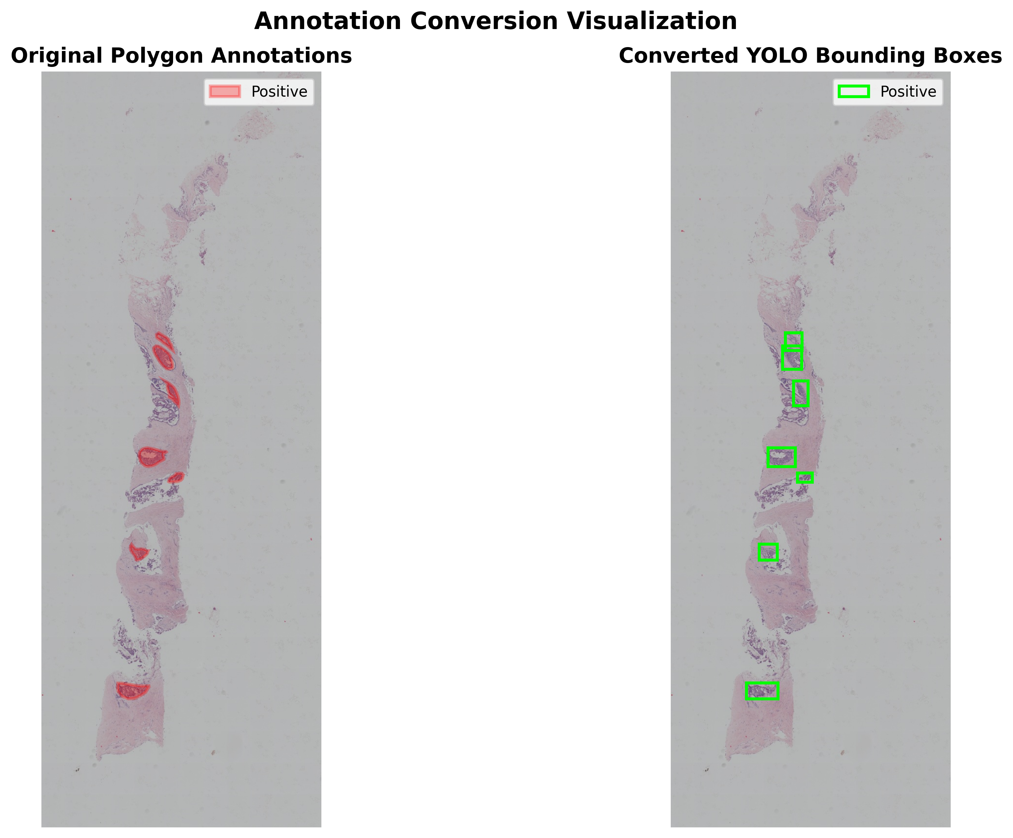

Figure 1 – Example from the BCNB (38) dataset with the original annotations (left) and the converted yolo bounding boxes (right).

### Nuclei

Nuclei (39)

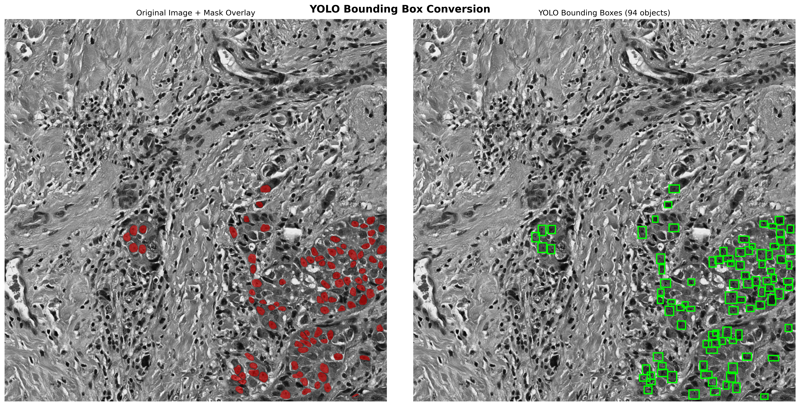

Figure 2 – Example from the Nuclei (39) dataset with the original annotations (left) and the converted yolo bounding boxes (right).

### TNBC

TNBC (40)

**11 patients, train/val/test split:**

**- Train: Patients 01 to 09**

**- Val: Patient 10**

**- Test: Patient 11**

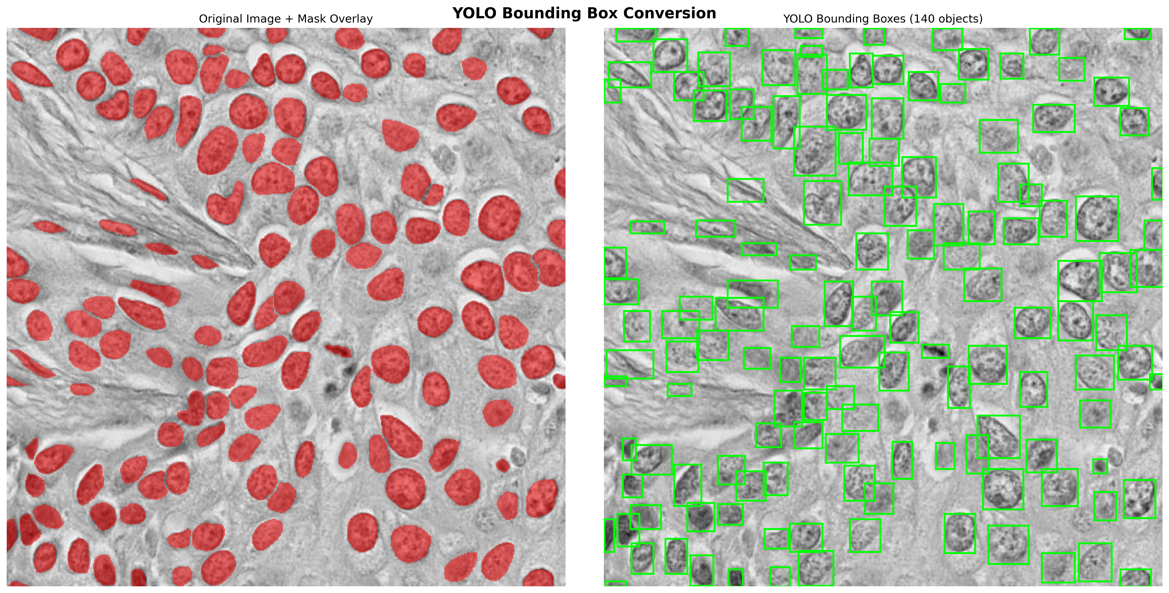

Figure 3 – Example from the TNBC (40) dataset with the original annotations (left) and the converted yolo bounding boxes (right).

### MoNuSAC

MoNuSAC (41)

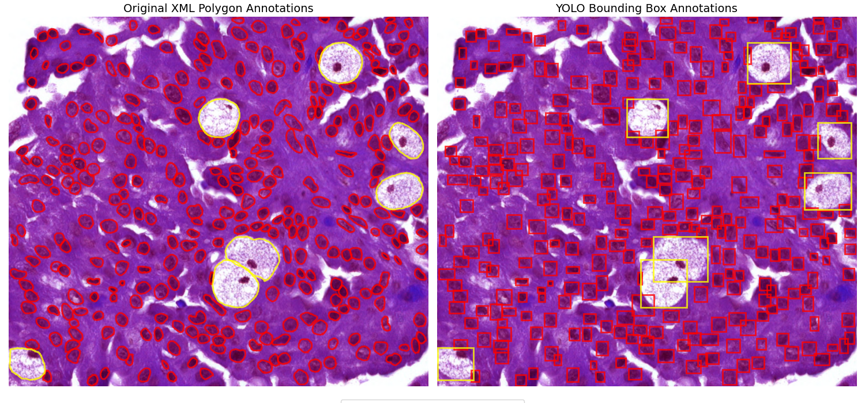

Figure 4 – Example from the MoNuSAC (41) dataset with the original annotations (left) and the converted yolo bounding boxes (right).

### CryoNuSeg

CryoNuSeg (42)

**10 organs, train/val/test split, random by organ:**

**- Train: All but adrenal gland and larynx**

**- Val: Adrenal gland**

**- Test: Larynx**

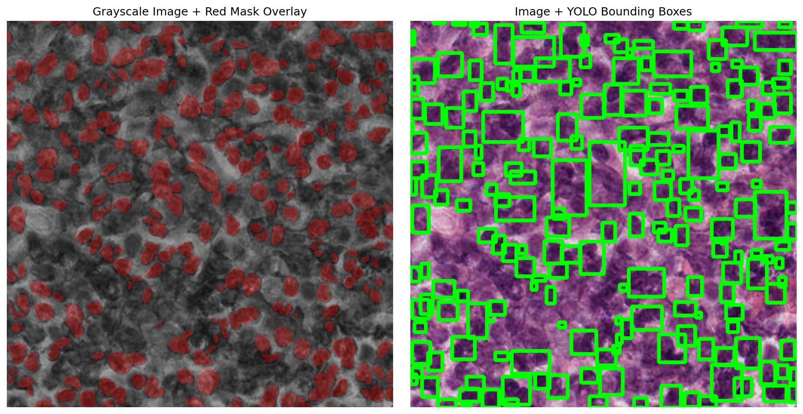

Figure 5 – Example from the CryoNuSeg (42) dataset with the original annotations (left) and the converted yolo bounding boxes (right).

## Object detection models

"You Only Look Once" (YOLO) (8) family

The "You Only Look Once" (YOLO) (8) object detection algorithm was initially introduced in 2015. The YOLO architecture managed to revolutionize real-time object detection by unifying region proposal and classification within a single neural network. This approach divided the image into a grid, directly predicting bounding boxes and class probabilities for each cell, which significantly reduced computation time and enabled end-to-end learning. YOLOv1 utilized a simplified CNN backbone and was good at accelerating the detection process. However, it faced challenges with small objects and spatial constraints, with each grid cell only predicting two boxes and having limited context.

The YOLO series has since undergone a decade of continuous evolution (45), progressing through numerous versions including YOLOv2, YOLOv3, YOLOv4, YOLOv5, YOLOv6, YOLOv7, YOLOv8, YOLOv9, YOLOv10, YOLOv11, and culminating in the recently unveiled YOLOv12. Each iteration introduced incremental technological advancements aimed at enhancing speed, detection accuracy, and computational efficiency. Beginning with YOLOv2 (45–47) this version built upon YOLOv1 by improving the resolution at which the model operated by incorporating techniques like batch normalization and anchor boxes from Faster R-CNN to improve training and performance. YOLOv3 (45,46,48) further advanced detection capabilities by implementing multi-scale predictions through Feature Pyramid Networks (FPN) and a deeper network architecture, Darknet-53, which specifically allowed for better detection of smaller objects. YOLOv4 (45,46,49) marked a significant point by integrating advanced features like CSPDarknet-53 and PANet in its architecture with Mish activation, alongside new data augmentation techniques like Mosaic and CutMix, setting new standards for speed and accuracy. Subsequently, YOLOv5 introduced by Ultralytics (45,46,50), focused on ease of use and performance, providing a streamlined PyTorch-based framework with improved backbone, neck, and head designs and it also featured an auto-anchor learning which adjusted the sizes of anchors during training. YOLOv6 (45,46,51) introduced a novel backbone to the YOLO architectures, EfficientRep with RepOptimizer focusing on efficiency. YOLOv7 (45,46,52) brought in a trainable bag-of-freebies and the Extended Efficient Layer Aggregation Network (E-ELAN) which achieved increased efficiency. YOLOv8 (45,46,50), also from Ultralytics (50), refined the architecture with the C2f module and transitioned to an anchor-free detection allowing for more specialized and simpler detection. YOLOv9 (45,46,53) addressed information degradation in deep networks by introducing the Generalized Efficient Layer Aggregation Network (GELAN) architecture and Programmable Gradient Information (PGI). YOLOv10 (45,46,54) achieved remarkable real-time efficiency by eliminating non-maximum suppression (NMS) and implementing a dual assignment strategy, along with architectural innovations like lightweight classification heads. The latest before YOLOv12, YOLOv11 (45,46,50), integrated the C3k2 block, SPPF, and C2PSA (Convolutional block with Parallel Spatial Attention) for enhanced feature extraction and spatial attention, balancing precision and efficiency for diverse applications.

YOLOv12 (45,46,50,55), introduced in February 2025, although based on the YOLO framework has made a significant shift in approach from its predecessors, moving towards an attention-centric design achieving state-of-the-art performance in both accuracy and efficiency while maintaining real-time detection capabilities. Unlike previous YOLO methods that primarily relied on CNN-based improvements for speed and accuracy, YOLOv12 integrates attention mechanisms while maintaining the high inference speed for real-time object detection (46,55) and thus, challenging the traditional view that attention-based models are too slow for real-time. YOLOv12 has managed to achieve this through innovations such as the Area Attention module, which reduces computational complexity and maintains a large receptive field, and Residual Efficient Layer Aggregation Networks (R-ELAN), designed to improve feature aggregation and address optimisation challenges, particularly in larger models. Additional architectural refinements include using FlashAttention to handle memory access issues, adjusting the MLP ratio, implementing attention with convolutions for efficiency, removing positional encoding, and incorporating a large separable convolution (Position Perceiver) to aid positional perception.

The development of YOLOv12 involved extensive analyses (55) to validate its design and performance. Comparative studies demonstrate that YOLOv12 achieves state-of-the-art results in accuracy (mAP) with superior speed (latency) and reduced computational cost (FLOPs) compared to popular methods like YOLOv6, YOLOv8, YOLOv10, YOLOv11, and RT-DETR variants across different model scales. Ablation studies specifically confirmed the effectiveness of R-ELAN (showing its necessity for stable training in larger models) and Area Attention (demonstrating significant speedups). Diagnostic studies also evaluated various architectural choices, including attention implementation methods, the hierarchical design, training epochs, the Position Perceiver, positional embedding, MLP ratio, and the impact of FlashAttention. Moreover, visualisations through heatmaps show YOLOv12's improved object perception compared to earlier versions.

YOLOv12, just as previous versions of the YOLO framework, is developed in a family of different model scales. These scales represent different trade-offs between accuracy, inference speed (latency), computational cost (FLOPs), and the number of parameters. There are five scales for YOLOv12 denoted by their suffixes: YOLOv12-N (Nano), YOLOv12-S (Small), YOLOv12-M (Medium), YOLOv12-L (Large), and YOLOv12-X (Extra Large). As the scale increases from N to X, the models generally become more accurate but also require more computation, have more parameters, and exhibit higher inference latency. This allows users to choose the variant that best fits their specific needs, whether prioritising maximum speed (e.g., YOLOv12-N) or highest accuracy (e.g., YOLOv12-X).

Despite its recent introduction, YOLOv12 has already seen various applications with promising results. It has been applied to early detection of sexually transmitted diseases (56), tracking of unmanned aerial vehicles (57), fruit detection (58,59), and marine litter detection (60,61) outperforming its predecessors. These results confirm again its ability and suitability to object detection tasks.

Real-Time DEtection TRansformer (RT-DETR) (59,62,63) provides an alternative approach that removes the need for non-maximum suppression through the use of an end-to-end transformer. RT-DETR is a redesigned version of DETRs with a focus on increasing computational efficiency while maintaining/increasing accuracy. The traditional Transformer encoder is substituted for a hybrid encoder which allows for increased speed by separately processing the intra-scale interaction and cross-scale fusion of features. The increase in detection accuracy is achieved through a query selection mechanism. RT-DETRv2 (63) improves upon its predecessor through an improved training strategy, specifically dynamic data augmentation and scale-adaptive hyperparameters. It improves multi-scale detection through the introduction of Selective Multi-Scale Sampling.

YOLO-World (64) is an extension of the YOLO approach based on YOLOv8 [11] with open-vocabulary detection capabilities through vision-language modeling. Its incorporation of vision-language modeling demonstrated an increased capacity of identifying a broad array of objects in zero-shot scenarios with high efficiency. YOLO-World introduces a Re-parameterizable Vision-Language Path Aggregation Network (RepVL-PAN) which allows interaction between visual and linguistic information and region-text contrastive loss aligning visual regions with textual descriptions. It demonstrated an increased ability of detecting objects making it suitable for real-world applications.

YOLOE (65) is another extension of the YOLO approach based on YOLOv8 [11] and YOLOv11 [11] that was designed for object detection and instance segmentation of images guided through prompt mechanisms. YOLOE supports text prompts through its Re-parameterizable Region-Text Alignment (RepRTA) strategy, it also supports visual prompts through Semantic Activated Visual Prompt Encoder (SAVPE) and it also allows for prompt-free scenario through a Lazy Region-Prompt Contrast (LRPC) strategy. Its ability to integrate contextual information through its prompt-guided approach might be beneficial as the identification of context-relevant information is one of the most important preprocessing steps (66).

## Performance evaluation

Although it is a common pratice, the assesstment of performance through a single performance metric may be perilous (67,68) if the metric does not cover all relevant aspects leading to a misleading and biased assessment.

Precision

Recall

F1

IoU

mAP@50

mAP@50-95

Precision refers to the percentage positive predictions that are actually correct and can be computed as the ratio of true positives (TP) (correct detection of a class when compared to the ground truth) to the sum of true positives and false positives (FP) (incorrect detection of a class as nothing actually exists when compared to the ground truth). Precision evaluates the ability to avoid false alarms (false positives) and can be computed through the following formula:

$$Precision= \frac{TP}{TP+FP}$$

Recall refers to the percentage of actual positives that are correctly identified and can be computed as the ratio of true positives to the sum of true positives and false negatives (FN) (incorrect detection of a class as nothing was detected when compared to the ground truth). Recall evaluates the ability to avoid missing detections (false negatives) and can be computed through the following formula:

$$Recall= \frac{TP}{TP+FN}$$

F1 score refers to the harmonic mean of precision and recall which is balanced measure of performance. As it uses both precision and recall it accounts for both false positives and false negatives, it is especially relevant when both precision and recall are important. It can be computed through the following formula:

$$F1= \frac{2*Precision*Recall}{(Precision+Recall)}$$

Intersection over Union (IoU) refers to the overlap between predicted and true bounding boxes and is computed as the ratio between the intersection area and union area of two bouding boxes. IoU evaluates the ability to deliniate object boundaries rather than simply detection and can be computed through the following formulas:

$$IoU= \frac{Intersection area}{Union area}$$

Mean Average Precision at an IoU threshold of 0.5 (mAP@50) represents the Average Precision (AP) (area under the precision-recall curve) computed for each class when detections are correct and they reached an IoU of at least 0.5 with true bounding boxes.

$$mAP@50= \frac{1}{|C|}\sum_{c∈C}{{AP}_{c}(IoU≥0.5)}$$

Where *C* represents the set of classes and c represents a single class of *C*.

Mean Average Precision at IoU thresholds from 0.5 to 0.95 (mAP@50-95) represents the AP scores across multiple IoU threshold from 0.5 to 0.95 with an increment of 0.05 and it captures the ability to localize across varying levels of requirements, thus penalizing detections that are only marginally aligned with true objects. mAP@50-95 can be computed throught he following formula:

$$mAP@50-95= \frac{1}{|C|}\sum_{c∈C}{(\frac{1}{|T|}\sum_{t∈T}{{AP}_{c}(IoU≥t)})}$$

Where *C* represents the set of classes and *c* represents a single class of *C*, and T represents the set of thresholds {0.5, 0.55, ..., 0.95}.

# Results

The latest versions of YOLO (v8 to v12) have been compared against each other. The training procedure has been done on the same random subset of 70% of the original dataset, while the validation and testing subsets contained 20% and 10%, respectively. They were trained for 50 epochs across the entire training set (with images that have been rescaled to 640x640) with batches of 16 using the AdamW optimization with a starting learning rate of 1e-4 which will be reduced to 1e-6 during the training process. A small penalty to large weights is added through a weight decay of 5e-4. They used a training learning rate warmup of 3 epochs, which stabilizes the training as the initial learning is reached through gradual increase.

To reduce the possibility of overfitting the models even further, data augmentation was also applied. The training images in the HSV format were randomly shifted as hue=0.015, saturation=0.7 and value=0.4 allowing the model to be invariant to lighting conditions. The images were also augmented through random rotations of up to ±10 degrees, translations of up to 10% on either axis and random zoom-ins/zoom-outs of up to 20%. Mixup augmentations were used in the training process which combine two images into a single composite one increasing generalizability by introducing noise and variability. While mosaic augmentations creates combinations of multiple images to simulate high complexity conditions. Mosaic augmentations were disabled for the last 10 epochs to allow the model stabilize.

All results presented are on the test set.

## BCNB

BCNB (38)

Due to the large size of the wsi histology images, a compression must be made to increase the efficiency and reduce both the storage size and inference time of neural network models (43). It has been shown that downsampling of 16x can actually improve the precision of object detection models while slightly lowering recall on renal WSI histology images (43) with the optimal downsampling being at 8x. It has also been shown that compression is a available option for further downsizing the high resolution images (43) with an optimal rate of 40%. It was also shown that lower resolution images can be beneficial for the performance of segmentation models (44).

glass histology slide into a Whole Slide Image

Table 2 – Results of object detection models on the BCNB (38) dataset

|  |  |  |  |  |  |  |  |
| --- | --- | --- | --- | --- | --- | --- | --- |
| **Model/Metric** | **mAP@50** | **mAP@50-95** | **Mean F1** | **Mean Precision** | **Mean Recall** | **Inference Time [ms]** | **Computational Cost [GFLOPs]** |
| RT-DETR | 0.183 | 0.085 | **0.263** | 0.270 | **0.257** | 1010.3 | 103.4 |
| YOLOv8 | 0.231 | 0.126 | 0.200 | 0.376 | 0.136 | 210.9 | 28.4 |
| YOLOv9 | 0.268 | 0.143 | 0.166 | **0.469** | 0.101 | 205.8 | 26.7 |
| YOLOv10 | 0.281 | 0.151 | 0.117 | 0.519 | 0.066 | 126.7 | 24.5 |
| YOLOv11 | 0.266 | 0.147 | 0.247 | 0.411 | 0.176 | 148.2 | 21.3 |
| YOLOv12 | **0.285** | **0.155** | 0.226 | 0.460 | 0.150 | 150.2 | **21.2** |
| YOLOE | 0.243 | 0.123 | 0.265 | 0.340 | 0.218 | 169.6 | 35.3 |
| YOLOv8-Worldv2 | 0.252 | 0.141 | 0.191 | 0.425 | 0.123 | 135.6 | 32.6 |

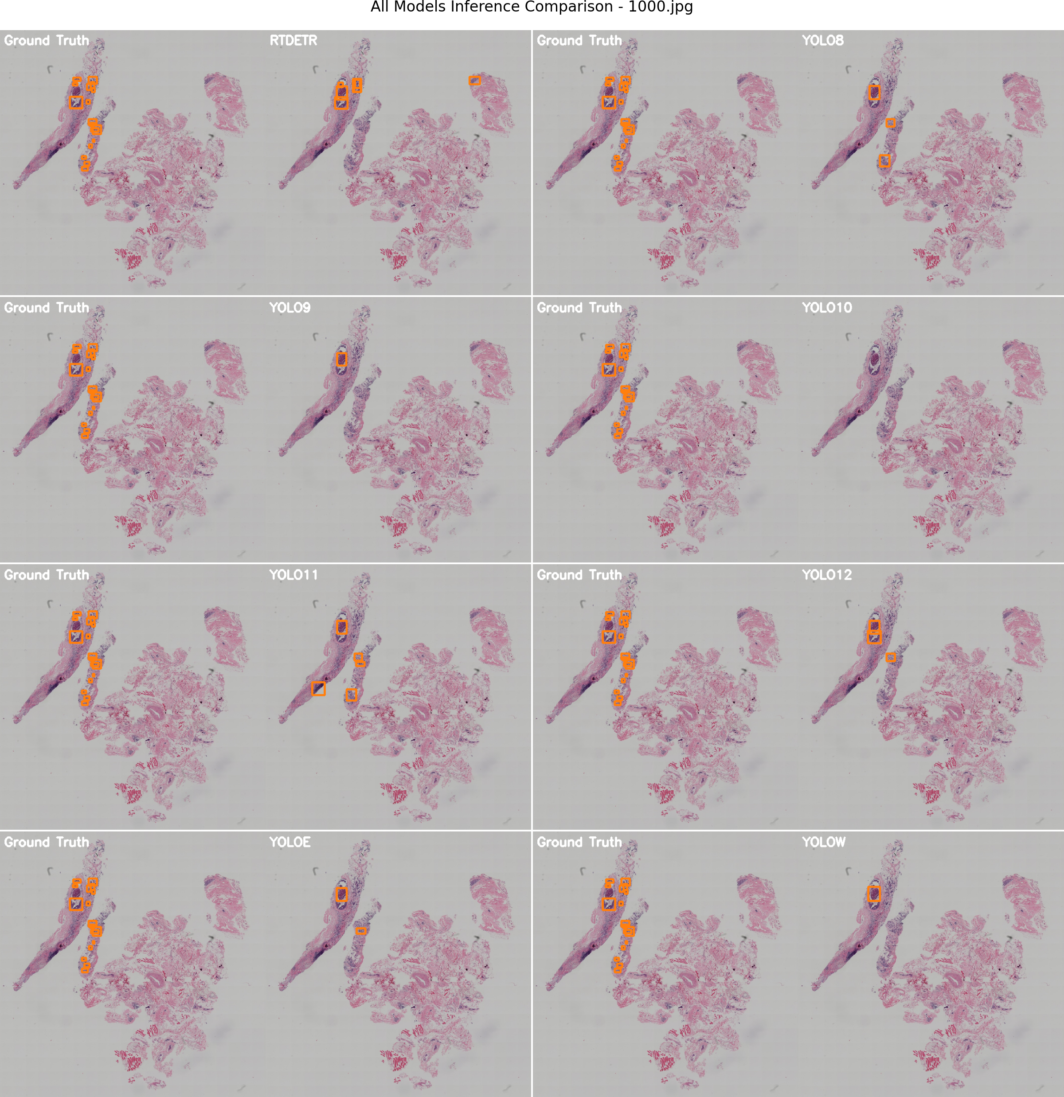

Figure 6 – Example from the BCNB (38) dataset with the original annotations (left) and the converted yolo bounding boxes (right).

## Nuclei

Nuclei (39)

Table 3 – Results of object detection models on the Nuclei (39) dataset

|  |  |  |  |  |  |  |  |
| --- | --- | --- | --- | --- | --- | --- | --- |
| **Model/Metric** | **mAP@50** | **mAP@50-95** | **Mean F1** | **Mean Precision** | **Mean Recall** | **Inference Time [ms]** | **Computational Cost [GFLOPs]** |
| RT-DETR | 0 | 0 | 0 | 0 | 0 | 1123.8 | 103.4 |
| YOLOv8 | 0.362 | 0.214 | 0.342 | 0.504 | 0.259 | 301.8 | 28.4 |
| YOLOv9 | 0.37 | 0.226 | 0.39 | 0.48 | 0.329 | 211.9 | 26.7 |
| YOLOv10 | 0.353 | 0.218 | 0.379 | 0.439 | 0.334 | 141.3 | 24.5 |
| YOLOv11 | 0.402 | **0.242** | 0.433 | 0.47 | 0.401 | 155.6 | 21.3 |
| YOLOv12 | 0.318 | 0.193 | 0.385 | 0.318 | **0.489** | 187.7 | **21.2** |
| YOLOE | **0.41** | 0.222 | **0.436** | **0.431** | 0.441 | 212.2 | 35.3 |
| YOLOv8-Worldv2 | 0.346 | 0.222 | 0.304 | 0.521 | 0.214 | 150.9 | 32.6 |

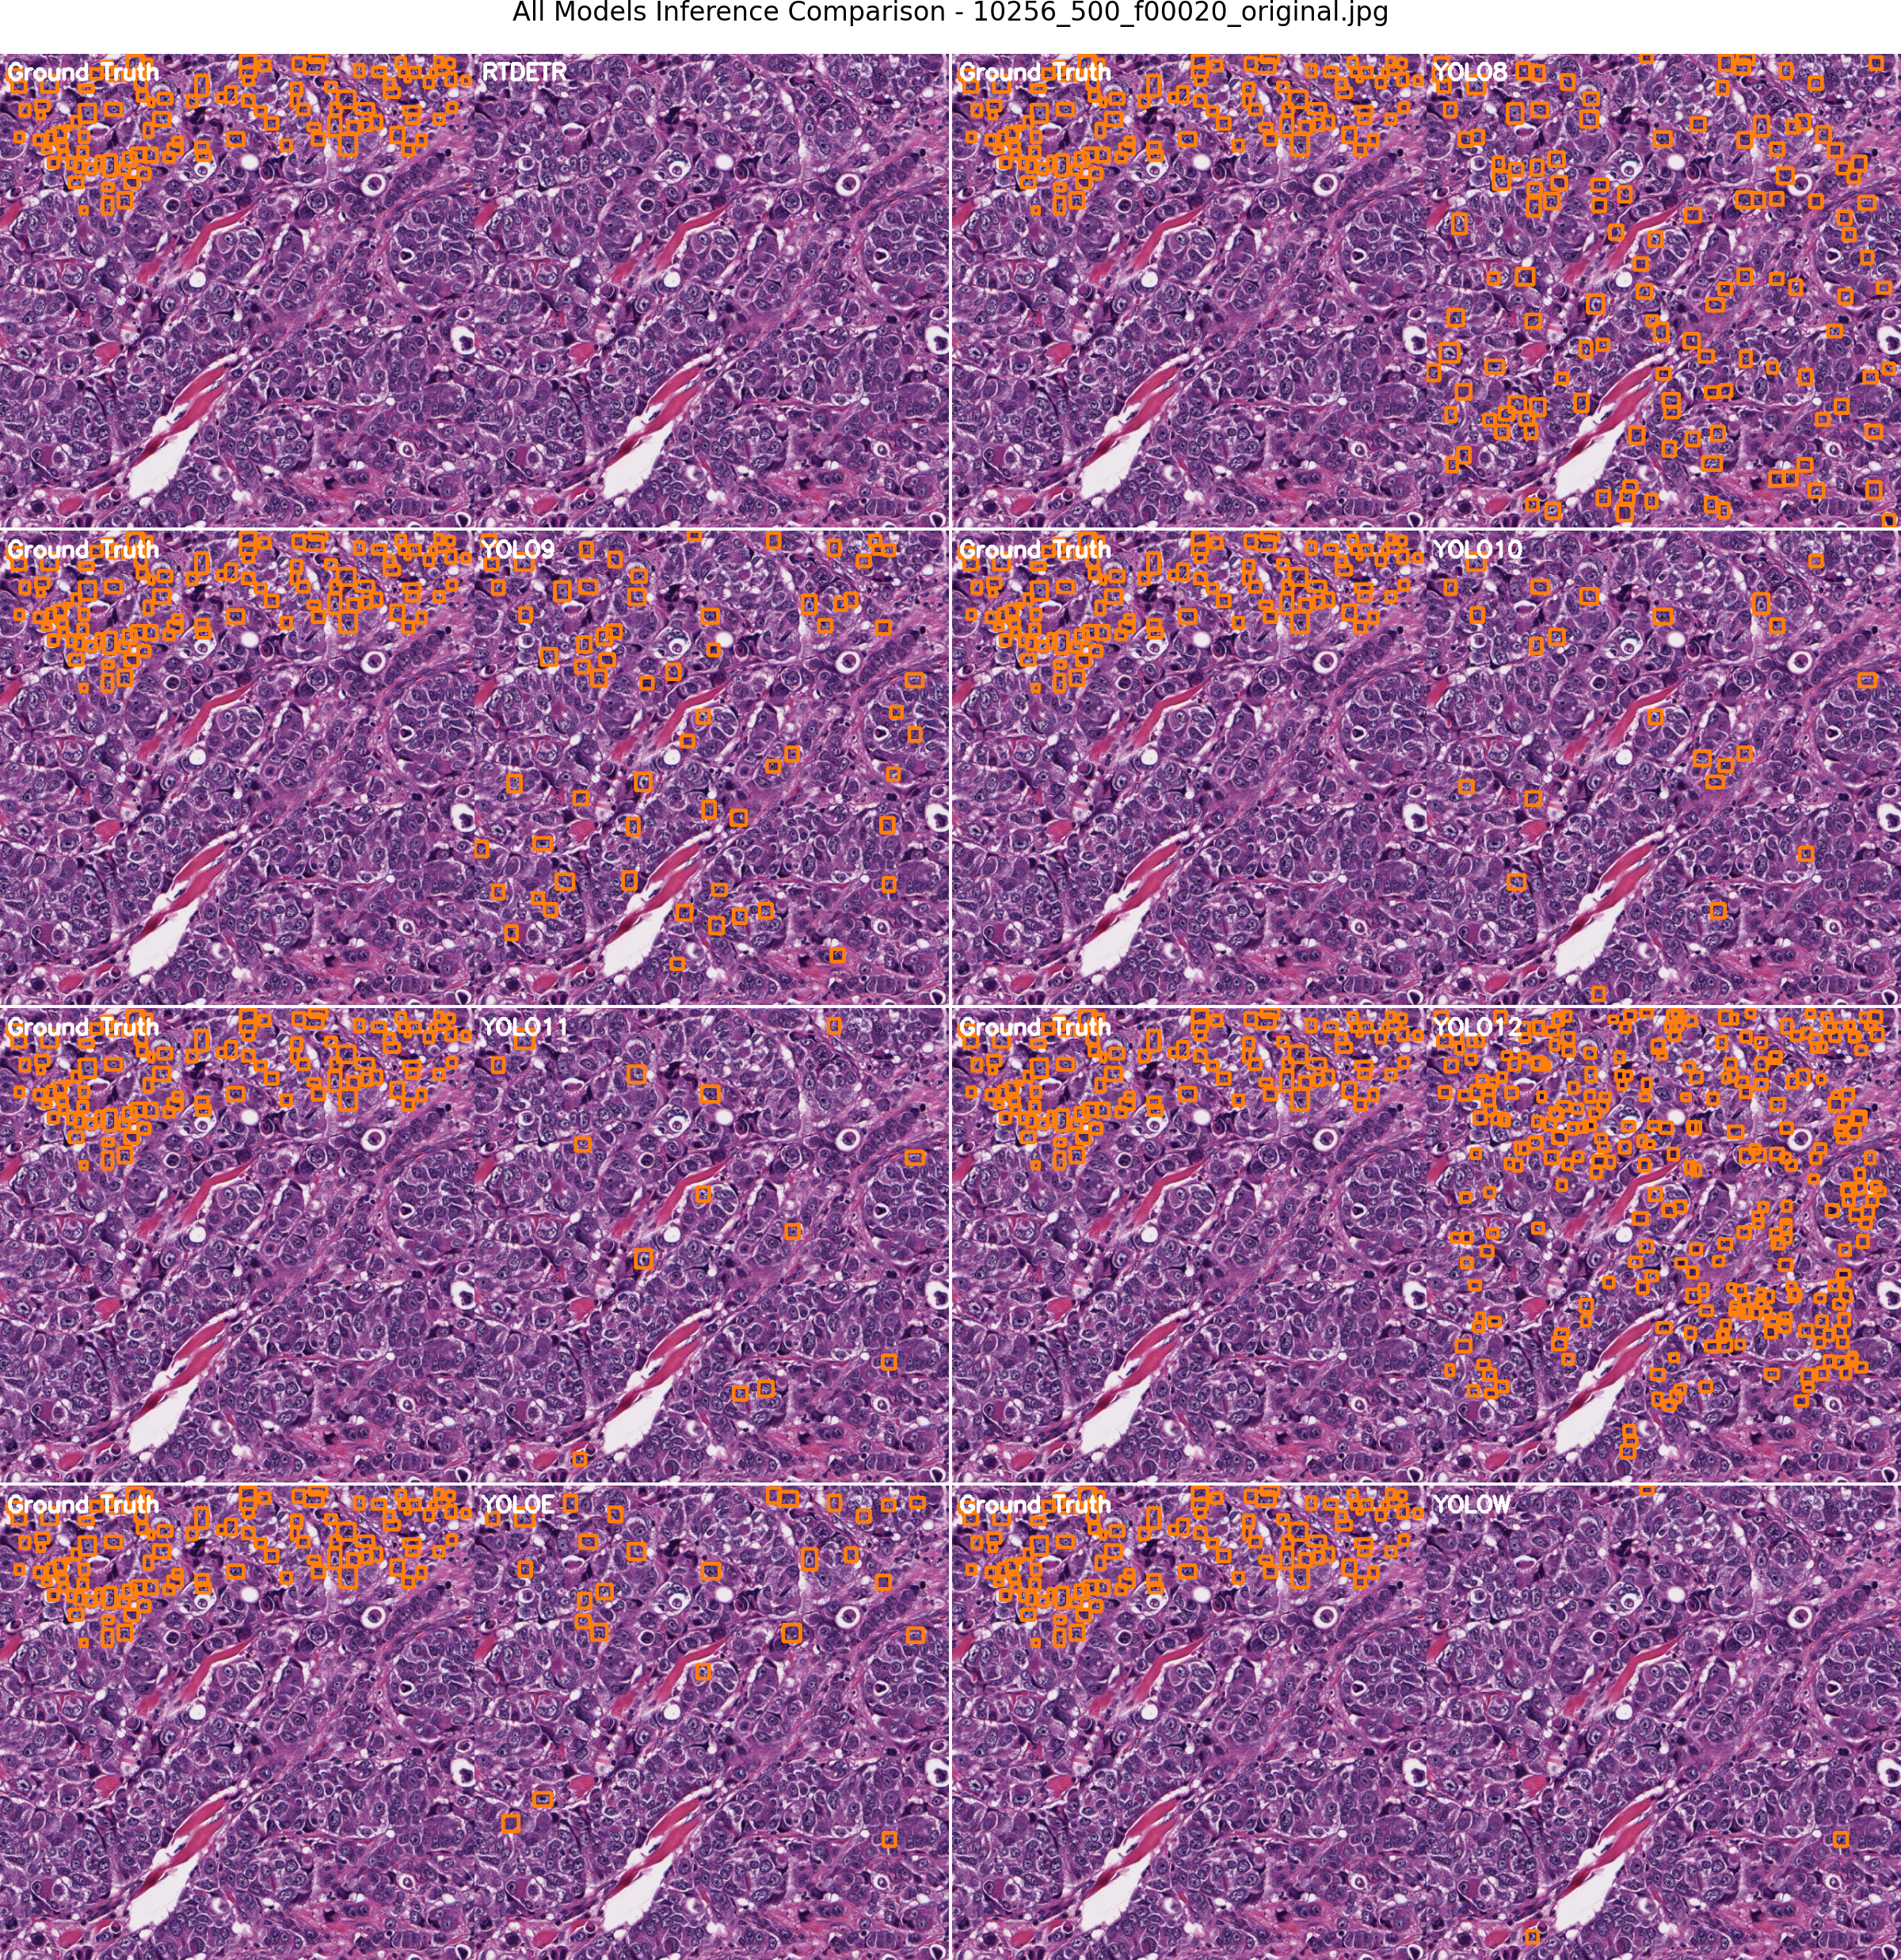

Figure 7 – Example from the Nuclei (39) dataset with the original annotations (left) and the converted yolo bounding boxes (right).

## TNBC

TNBC (40)

**11 patients, train/val/test split:**

**- Train: Patients 01 to 09**

**- Val: Patient 10**

**- Test: Patient 11**

Table 4 – Results of object detection models on the TNBC (40) dataset

|  |  |  |  |  |  |  |  |
| --- | --- | --- | --- | --- | --- | --- | --- |
| **Model/Metric** | **mAP@50** | **mAP@50-95** | **Mean F1** | **Mean Precision** | **Mean Recall** | **Inference Time [ms]** | **Computational Cost [GFLOPs]** |
| RT-DETR | 0.334 | 0.182 | 0.388 | 0.249 | 0.882 | 1193.6 | 103.4 |
| YOLOv8 | 0.924 | 0.650 | 0.895 | 0.921 | 0.871 | 315.0 | 28.4 |
| YOLOv9 | **0.930** | 0.597 | 0.885 | 0.892 | 0.878 | 229.8 | 26.7 |
| YOLOv10 | 0.888 | 0.642 | 0.861 | 0.884 | 0.839 | 177.7 | 24.5 |
| YOLOv11 | 0.923 | 0.672 | 0.900 | **0.936** | 0.866 | 167.6 | 21.3 |
| YOLOv12 | **0.930** | **0.676** | **0.906** | 0.922 | **0.890** | 189.5 | **21.2** |
| YOLOE | 0.920 | 0.601 | 0.899 | 0.921 | 0.878 | 241.1 | 35.3 |
| YOLOv8-Worldv2 | 0.899 | 0.649 | 0.874 | 0.921 | 0.831 | 170.7 | 32.6 |

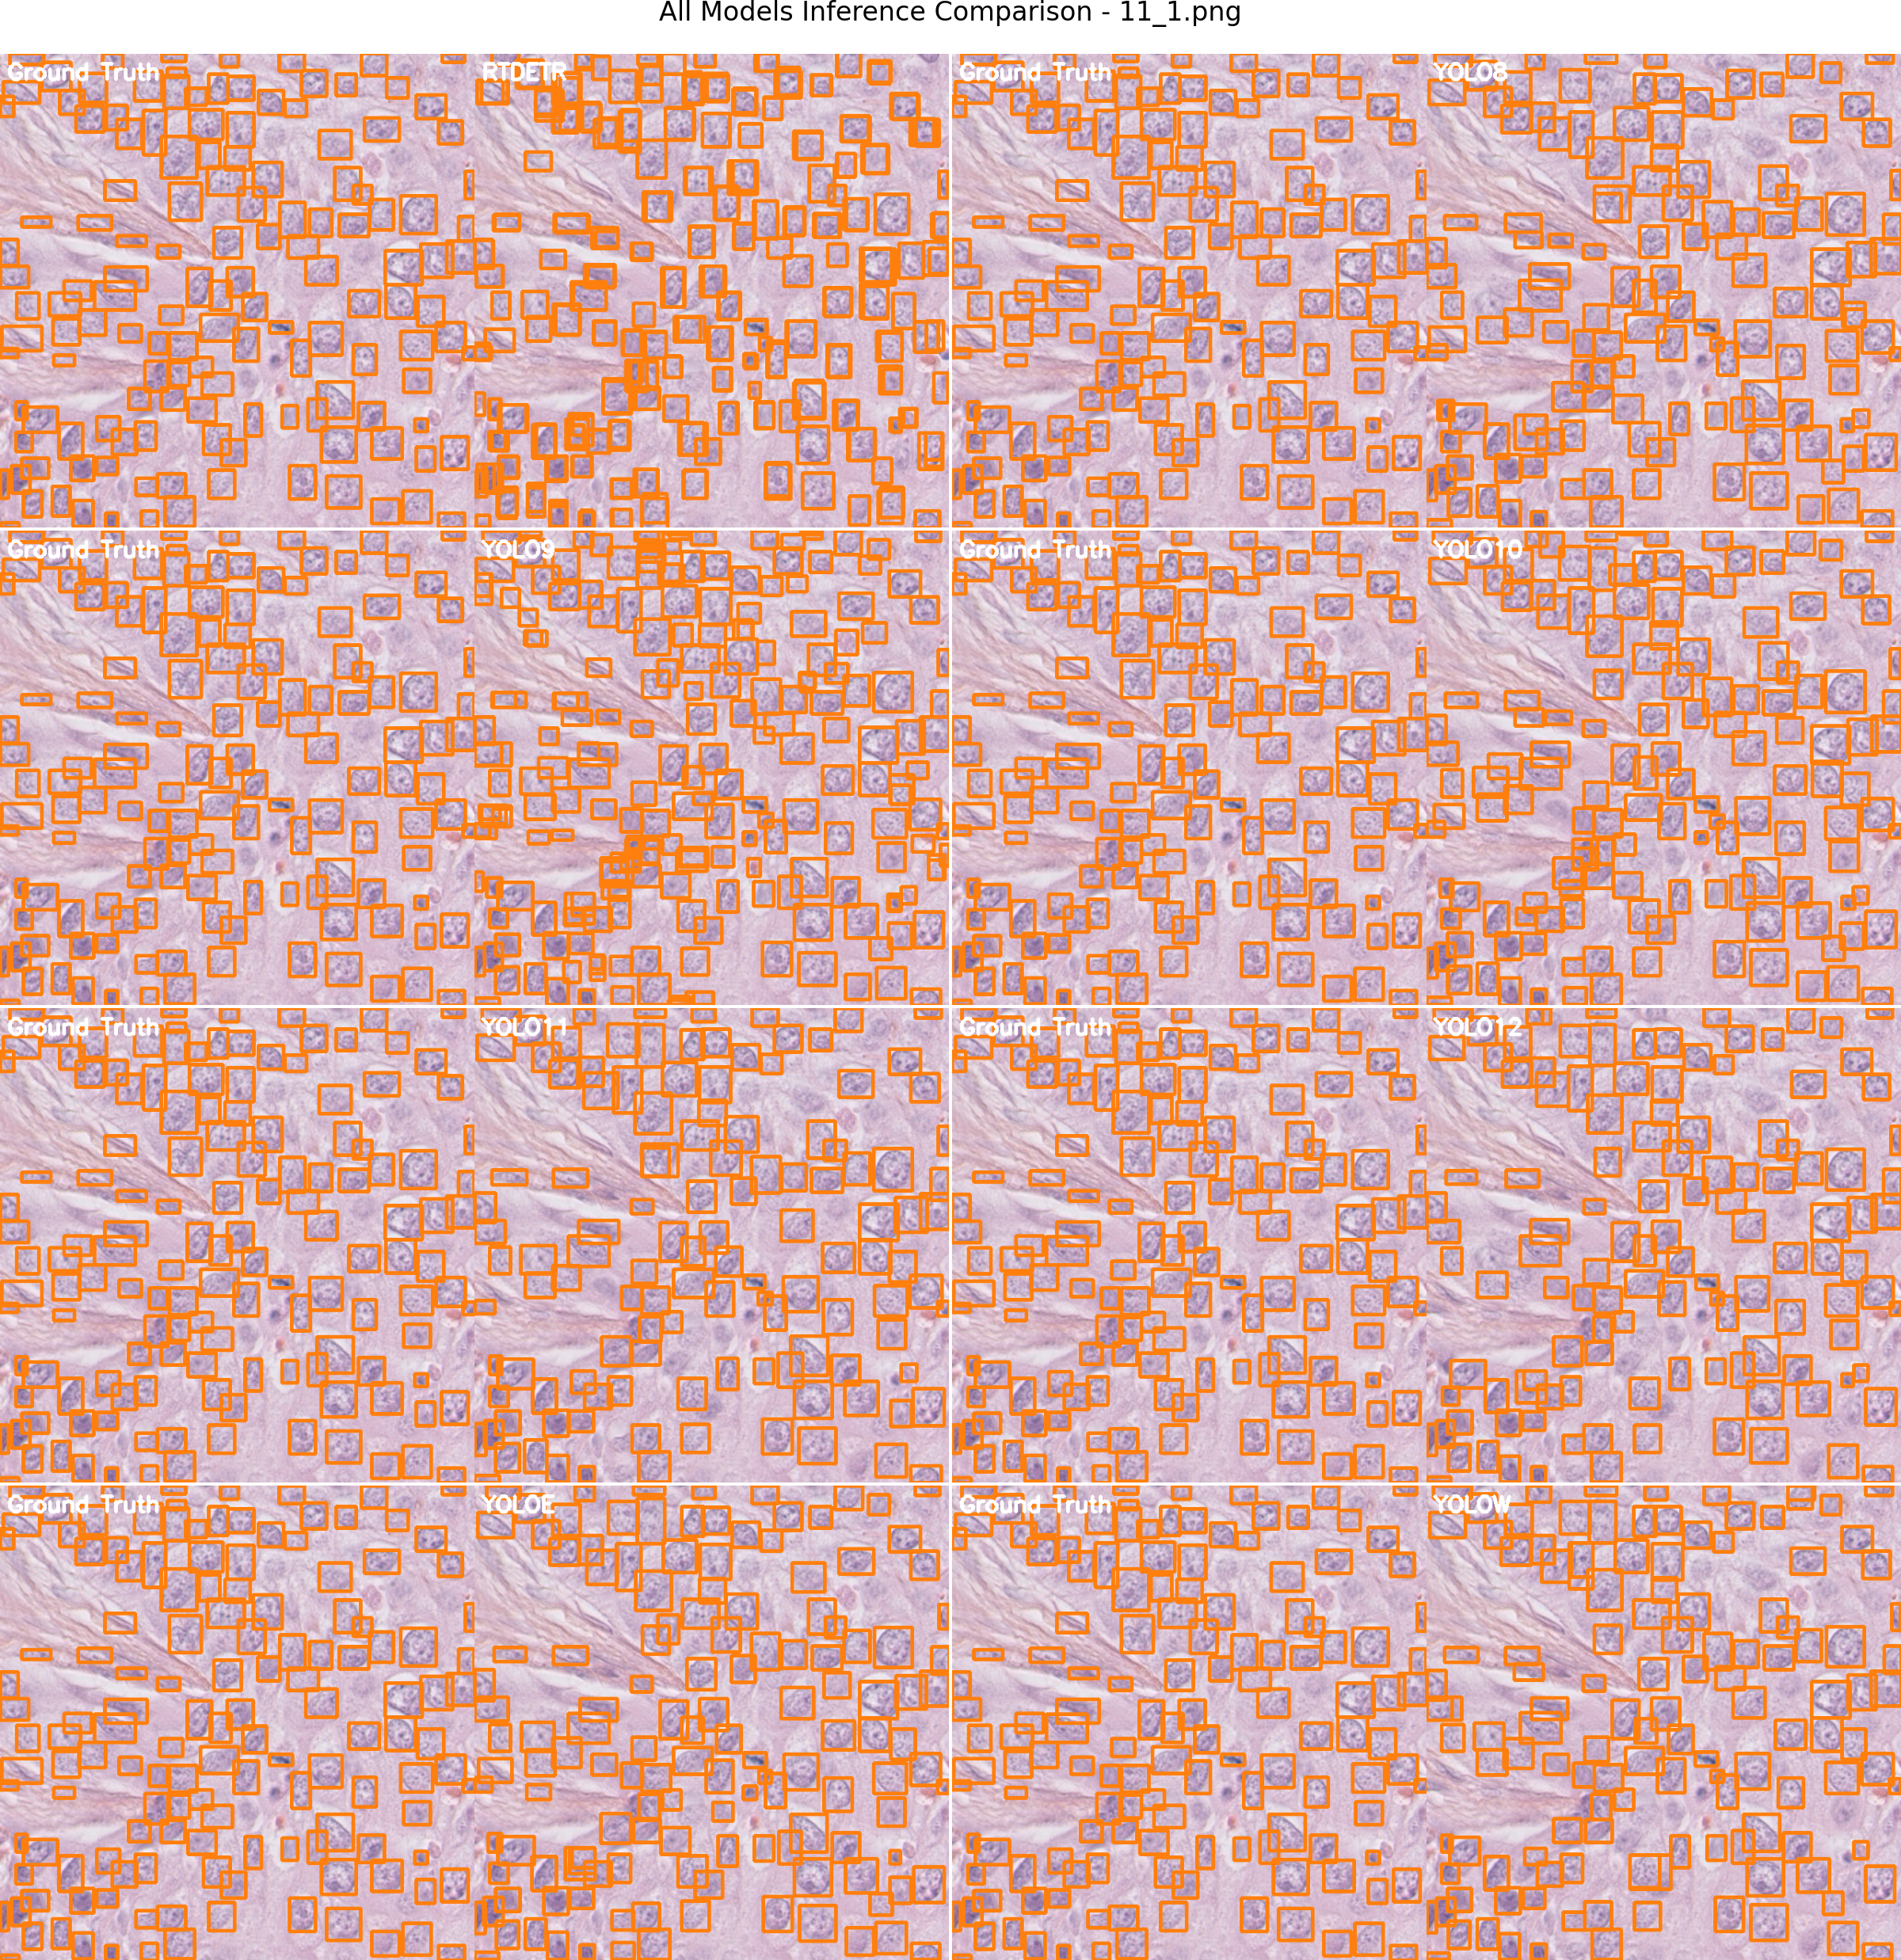

Figure 8 – Example from the TNBC (40) dataset with the original annotations (left) and the converted yolo bounding boxes (right).

## MoNuSAC

MoNuSAC (41)

Table 5 – Results of object detection models on the MoNuSAC (41) dataset

|  |  |  |  |  |  |  |  |
| --- | --- | --- | --- | --- | --- | --- | --- |
| **Model/Metric** | **mAP@50** | **mAP@50-95** | **Mean F1** | **Mean Precision** | **Mean Recall** | **Inference Time [ms]** | **Computational Cost [GFLOPs]** |
| RT-DETR | 0.306 | 0.069 | 0.230 | 0.449 | 0.203 | 1010.4 | 103.4 |
| YOLOv8 | 0.748 | 0.488 | 0.694 | 0.781 | 0.639 | **190.2** | 28.4 |
| YOLOv9 | 0.744 | 0.463 | 0.701 | 0.820 | 0.626 | 208.4 | 26.7 |
| YOLOv10 | 0.699 | 0.442 | 0.649 | 0.758 | 0.587 | 238.8 | 24.5 |
| YOLOv11 | **0.777** | **0.510** | 0.725 | **0.806** | 0.676 | 211.5 | 21.3 |
| YOLOv12 | 0.721 | 0.477 | 0.667 | 0.721 | 0.679 | 206.3 | **21.2** |
| YOLOE | 0.773 | 0.454 | **0.732** | 0.804 | **0.686** | 253.0 | 35.3 |
| YOLOv8-Worldv2 | 0.780 | 0.483 | 0.714 | 0.774 | 0.693 | 199.6 | 32.6 |

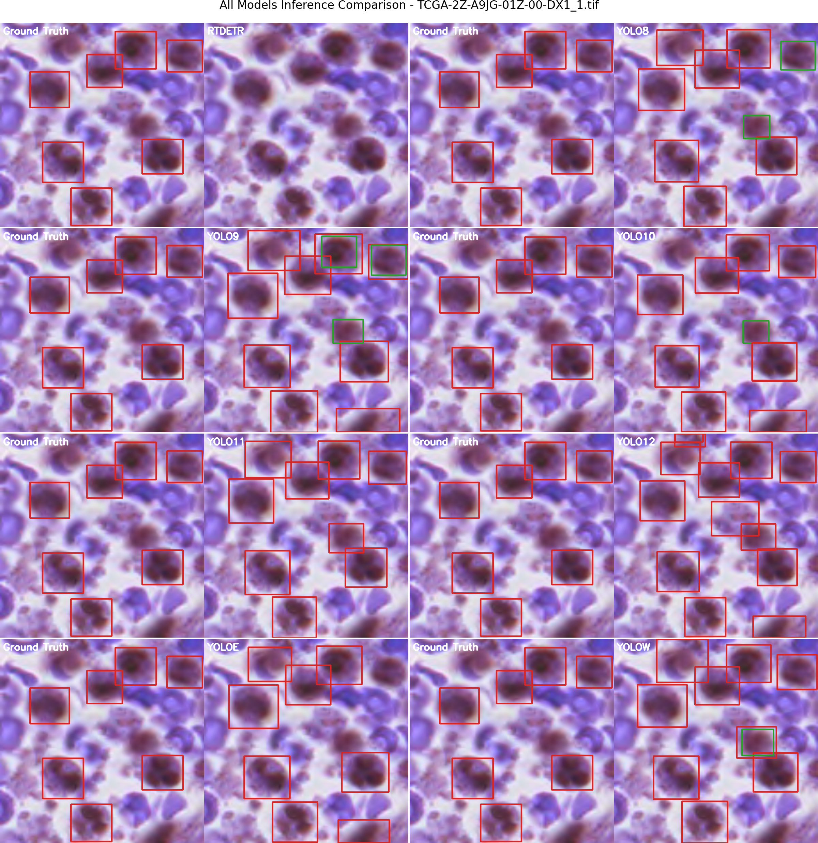

Figure 9 – Example from the MoNuSAC (41) dataset with the original annotations (left) and the converted yolo bounding boxes (right).

## CryoNuSeg

CryoNuSeg (42)

**10 organs, train/val/test split, random by organ:**

**- Train: All but adrenal gland and larynx**

**- Val: Adrenal gland**

**- Test: Larynx**

Table 6 – Results of object detection models on the CryoNuSeg (42) dataset

|  |  |  |  |  |  |  |  |
| --- | --- | --- | --- | --- | --- | --- | --- |
| **Model/Metric** | **mAP@50** | **mAP@50-95** | **Mean F1** | **Mean Precision** | **Mean Recall** | **Inference Time [ms]** | **Computational Cost [GFLOPs]** |
| RT-DETR | 0.031 | 0.014 | 0.072 | 0.056 | 0.104 | 778.9 | 103.4 |
| YOLOv8 | 0.773 | 0.469 | 0.737 | 0.727 | 0.748 | **169.4** | 28.4 |
| YOLOv9 | 0.746 | 0.453 | 0.711 | 0.690 | 0.733 | 170.2 | 26.7 |
| YOLOv10 | 0.675 | 0.455 | 0.668 | 0.694 | 0.643 | 186.9 | 24.5 |
| YOLOv11 | **0.781** | **0.506** | **0.762** | **0.767** | **0.757** | 216.2 | 21.3 |
| YOLOv12 | 0.704 | 0.407 | 0.695 | 0.702 | 0.688 | 179.0 | **21.2** |
| YOLOE | 0.747 | 0.425 | 0.720 | 0.724 | 0.717 | 241.2 | 35.3 |
| YOLOv8-Worldv2 | 0.754 | 0.419 | 0.724 | 0.745 | 0.705 | 186.9 | 32.6 |

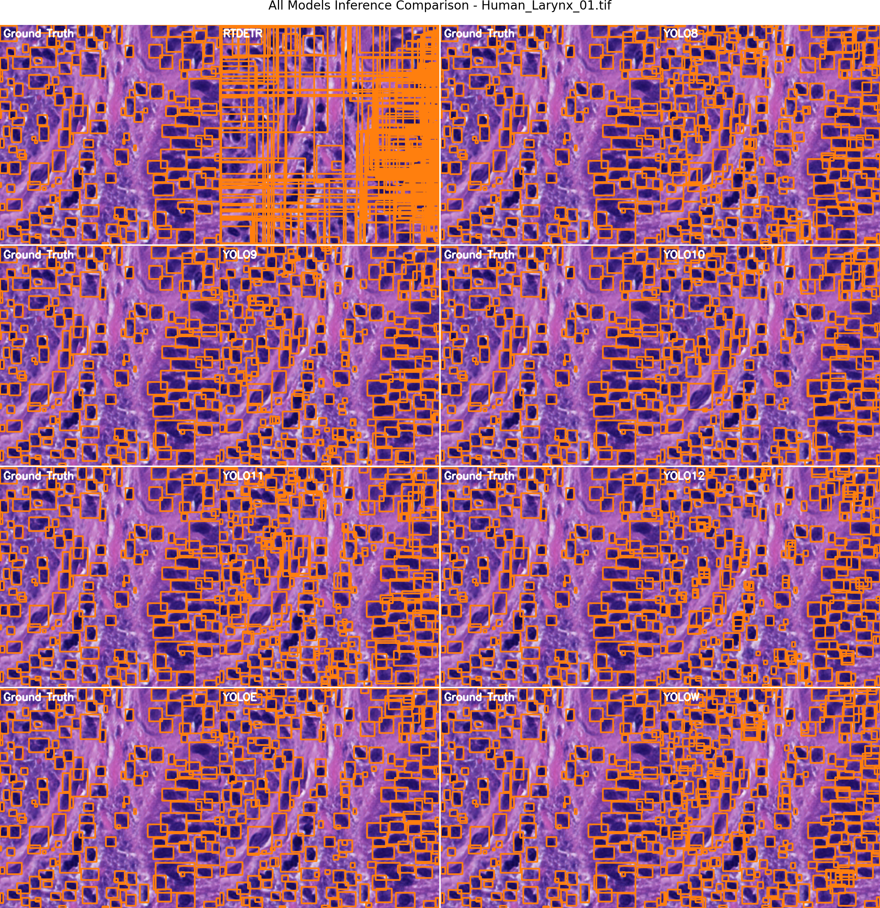

Figure 10 – Example from the CryoNuSeg (42) dataset with the original annotations (left) and the converted yolo bounding boxes (right).

# Conclusions

Future research should focus on several areas. One such area is the investigation of few-shot and zero-shot learning approaches to address the cases of rare pathologies where only a limited amount of data can be obtained. The development and investigation interpretability methodologies is a key requirement for clinical applications. An area that should not be ignored is the clinical validation of models to assess real-world performance of such automated detection systems.

# Data Availability

The datasets used in this work are openly available and can be found at:

* BCNB (38): https://bcnb.grand-challenge.org/
* Nuclei (39): https://andrewjanowczyk.com/use-case-1-nuclei-segmentation/
* TNBC (40): https://zenodo.org/records/2579118#.Yt5FWt_RaUk
* MoNuSAC (41): https://monusac-2020.grand-challenge.org/
* CryoNuSeg (42): https://www.kaggle.com/datasets/ipateam/segmentation-of-nuclei-in-cryosectioned-he-images

# Code Availability

The code that supports the findings of this work was written in Python and is openly available at: <https://github.com/ArdeleanRichard/YOLO-Histology/>.

# Competing Interests

The authors have declared that no competing interests exist.

# Authors’ contributions

Conceptualization, E.-R.A. and R.L.P.; methodology, E.-R.A. and R.L.P.; software, E.-R.A. and R.L.P.; validation, E.-R.A. and R.L.P.; formal analysis, E.-R.A. and R.L.P.; investigation, E.-R.A. and R.L.P.; data curation, E.-R.A. and R.L.P.; writing—original draft preparation, E.-R.A. and R.L.P.; writing—review and editing, E.-R.A. and R.L.P.; visualization, E.-R.A. and R.L.P.; supervision, E.-R.A. and R.L.P.; project administration, E.-R.A. and R.L.P. All authors have read and agreed to the published version of the manuscript.

# Funding

This work is supported by the project "Romanian Hub for Artificial Intelligence-HRIA", Smart Growth, Digitization and Financial Instruments Program, MySMIS no. 334906.

# Acknowledgement

# Bibliography

1. Pantanowitz L. Digital images and the future of digital pathology. J Pathol Inform. 2010 Aug 10;1:15.

2. Jain A, Perdomo D, Nagururu N, Li JA, Ward BK, Lauer AM, et al. SVPath: A Deep Learning Tool for Analysis of Stria Vascularis from Histology Slides. JARO J Assoc Res Otolaryngol. 2024 Aug;25(4):1–8.

3. Kurata N, Schachern PA, Paparella MM, Cureoglu S. Histopathologic Evaluation of Vascular Findings in the Cochlea in Patients With Presbycusis. JAMA Otolaryngol-- Head Neck Surg. 2016 Feb;142(2):173–8.

4. Guo Z, Liu H, Ni H, Wang X, Su M, Guo W, et al. A Fast and Refined Cancer Regions Segmentation Framework in Whole-slide Breast Pathological Images. Sci Rep. 2019 Jan 29;9(1):882.

5. Khened M, Kori A, Rajkumar H, Krishnamurthi G, Srinivasan B. A generalized deep learning framework for whole-slide image segmentation and analysis. Sci Rep. 2021 Jun 2;11(1):11579.

6. van der Laak J, Litjens G, Ciompi F. Deep learning in histopathology: the path to the clinic. Nat Med. 2021 May;27(5):775–84.

7. Cheng PM, Montagnon E, Yamashita R, Pan I, Cadrin-Chênevert A, Perdigón Romero F, et al. Deep Learning: An Update for Radiologists. Radiogr Rev Publ Radiol Soc N Am Inc. 2021;41(5):1427–45.

8. Redmon J, Divvala S, Girshick R, Farhadi A. You Only Look Once: Unified, Real-Time Object Detection [Internet]. arXiv; 2016 [cited 2025 May 26]. Available from: http://arxiv.org/abs/1506.02640

9. Narotamo H, Sanches JM, Silveira M. Segmentation of Cell Nuclei in Fluorescence Microscopy Images Using Deep Learning. In: Morales A, Fierrez J, Sánchez JS, Ribeiro B, editors. Pattern Recognition and Image Analysis. Cham: Springer International Publishing; 2019. p. 53–64.

10. Nair LS, R RP, Sugathan G, Gireesh KV, Nair AS. Mitotic Nuclei Detection in Breast Histopathology Images using YOLOv4. In: 2021 12th International Conference on Computing Communication and Networking Technologies (ICCCNT) [Internet]. 2021 [cited 2025 Aug 28]. p. 1–5. Available from: https://ieeexplore.ieee.org/document/9579969

11. Bal A, Das M, Satapathy SM. YOLO as a Region Proposal Network for Diagnosing Breast Cancer. In: 2021 Grace Hopper Celebration India (GHCI) [Internet]. 2021 [cited 2025 Aug 28]. p. 1–6. Available from: https://ieeexplore.ieee.org/document/9513988

12. Litjens G, Kooi T, Bejnordi BE, Setio AAA, Ciompi F, Ghafoorian M, et al. A survey on deep learning in medical image analysis. Med Image Anal. 2017 Dec 1;42:60–88.

13. Wang S, Yang DM, Rong R, Zhan X, Xiao G. Pathology Image Analysis Using Segmentation Deep Learning Algorithms. Am J Pathol. 2019 Sep 1;189(9):1686–98.

14. Janowczyk A, Madabhushi A. Deep learning for digital pathology image analysis: A comprehensive tutorial with selected use cases. J Pathol Inform. 2016 Jan 1;7(1):29.

15. Rong R, Sheng H, Jin KW, Wu F, Luo D, Wen Z, et al. A Deep Learning Approach for Histology-Based Nucleus Segmentation and Tumor Microenvironment Characterization. Mod Pathol Off J U S Can Acad Pathol Inc. 2023 Aug;36(8):100196.

16. van der Laak J, Litjens G, Ciompi F. Deep learning in histopathology: the path to the clinic. Nat Med. 2021 May;27(5):775–84.

17. Wahid F, Ma Y, Khan D, Aamir M, Bukhari SUK. arXiv.org. 2024 [cited 2025 Jun 3]. Biomedical Image Segmentation: A Systematic Literature Review of Deep Learning Based Object Detection Methods. Available from: https://arxiv.org/abs/2408.03393v2

18. Gurcan MN, Boucheron LE, Can A, Madabhushi A, Rajpoot NM, Yener B. Histopathological Image Analysis: A Review. IEEE Rev Biomed Eng. 2009;2:147–71.

19. Shen D, Wu G, Suk HI. Deep Learning in Medical Image Analysis. Annu Rev Biomed Eng. 2017 Jun 21;19(Volume 19, 2017):221–48.

20. Xing F, Yang L. Robust Nucleus/Cell Detection and Segmentation in Digital Pathology and Microscopy Images: A Comprehensive Review. IEEE Rev Biomed Eng. 2016;9:234–63.

21. Komura D, Ishikawa S. Machine Learning Methods for Histopathological Image Analysis. Comput Struct Biotechnol J. 2018 Jan 1;16:34–42.

22. Lu MY, Chen TY, Williamson DFK, Zhao M, Shady M, Lipkova J, et al. AI-based pathology predicts origins for cancers of unknown primary. Nature. 2021 Jun;594(7861):106–10.

23. Sheikhzadeh F, Ward RK, Niekerk D van, Guillaud M. Automatic labeling of molecular biomarkers of immunohistochemistry images using fully convolutional networks. PLOS ONE. 2018 Jan 19;13(1):e0190783.

24. Xu J, Luo X, Wang G, Gilmore H, Madabhushi A. A Deep Convolutional Neural Network for segmenting and classifying epithelial and stromal regions in histopathological images. Neurocomputing. 2016 May 26;191:214–23.

25. Hou L, Samaras D, Kurc TM, Gao Y, Davis JE, Saltz JH. Patch-based Convolutional Neural Network for Whole Slide Tissue Image Classification. Proc IEEE Comput Soc Conf Comput Vis Pattern Recognit. 2016;2016:2424–33.

26. Nir G, Hor S, Karimi D, Fazli L, Skinnider BF, Tavassoli P, et al. Automatic grading of prostate cancer in digitized histopathology images: Learning from multiple experts. Med Image Anal. 2018 Dec 1;50:167–80.

27. Rong R, Sheng H, Jin KW, Wu F, Luo D, Wen Z, et al. A Deep Learning Approach for Histology-Based Nucleus Segmentation and Tumor Microenvironment Characterization. Mod Pathol Off J U S Can Acad Pathol Inc. 2023 Aug;36(8):100196.

28. Salman ME, Çakirsoy Çakar G, Azimjonov J, Kösem M, Cedi̇moğlu İH. Automated prostate cancer grading and diagnosis system using deep learning-based Yolo object detection algorithm. Expert Syst Appl. 2022 Sep 1;201:117148.

29. Bamwenda J, Özerdem MS, Ayyıldız O, Akpolat V. A Hybrid Deep Learning Framework for Accurate Cell Segmentation in Whole Slide Images Using YOLOv11, StarDist, and SAM2. Bioengineering. 2025 Jun;12(6):674.

30. Kumar N, Verma R, Anand D, Zhou Y, Onder OF, Tsougenis E, et al. A Multi-Organ Nucleus Segmentation Challenge. IEEE Trans Med Imaging. 2020 May;39(5):1380–91.

31. Howard FM, Hieromnimon HM, Ramesh S, Dolezal J, Kochanny S, Zhang Q, et al. Generative adversarial networks accurately reconstruct pan-cancer histology from pathologic, genomic, and radiographic latent features. Sci Adv. 2024 Nov 15;10(46):eadq0856.

32. Ma Y, Jamdade S, Konduri L, Sailem H. AI in Histopathology Explorer for comprehensive analysis of the evolving AI landscape in histopathology. Npj Digit Med. 2025 Mar 12;8(1):156.

33. Liu H, Li X, Bamba AL, Song X, Brott BC, Litovsky SH, et al. Toward reliable calcification detection: calibration of uncertainty in object detection from coronary optical coherence tomography images. J Biomed Opt. 2023 Mar;28(3):036008.

34. Rizzieri N, Dall’Asta L, Ozoliņš M. Diabetic Retinopathy Features Segmentation without Coding Experience with Computer Vision Models YOLOv8 and YOLOv9. Vision. 2024 Sep;8(3):48.

35. Li C, Che S, Gong H, Ding Y, Luo Y, Xi J, et al. PI-YOLO: dynamic sparse attention and lightweight convolutional based YOLO for vessel detection in pathological images. Front Oncol [Internet]. 2024 Jul 29 [cited 2025 Jun 3];14. Available from: https://www.frontiersin.org/journals/oncology/articles/10.3389/fonc.2024.1347123/full

36. Neri G, Sharma S, Ghezzo B, Novarese C, Olivieri C, Tibaldi D, et al. Deep learning model for automatic detection of different types of microaneurysms in diabetic retinopathy. Eye. 2025 Feb;39(3):570–7.

37. Brehar R, Groza A, Damian I, Muntean G, Nicoară SD. Age-Related Macular Degeneration Biomarker Segmentation from OCT images. In: 2023 24th International Conference on Control Systems and Computer Science (CSCS) [Internet]. 2023 [cited 2025 Jun 12]. p. 444–51. Available from: https://ieeexplore.ieee.org/document/10214815

38. Xu F, Zhu C, Tang W, Wang Y, Zhang Y, Li J, et al. Predicting Axillary Lymph Node Metastasis in Early Breast Cancer Using Deep Learning on Primary Tumor Biopsy Slides. Front Oncol [Internet]. 2021 Oct 14 [cited 2025 Aug 20];11. Available from: https://www.frontiersin.org/journals/oncology/articles/10.3389/fonc.2021.759007/full

39. Janowczyk A, Madabhushi A. Deep learning for digital pathology image analysis: A comprehensive tutorial with selected use cases. J Pathol Inform. 2016 Jan 1;7(1):29.

40. Naylor P, Laé M, Reyal F, Walter T. Segmentation of Nuclei in Histopathology Images by Deep Regression of the Distance Map. IEEE Trans Med Imaging. 2019 Feb;38(2):448–59.

41. Verma R, Kumar N, Patil A, Kurian NC, Rane S, Graham S, et al. MoNuSAC2020: A Multi-Organ Nuclei Segmentation and Classification Challenge. IEEE Trans Med Imaging. 2021 Dec;40(12):3413–23.

42. Mahbod A, Schaefer G, Bancher B, Löw C, Dorffner G, Ecker R, et al. CryoNuSeg: A dataset for nuclei instance segmentation of cryosectioned H&E-stained histological images. Comput Biol Med. 2021 May 1;132:104349.

43. Peng C, Zhao K, Wiliem A, Zhang T, Hobson P, Jennings A, et al. To What Extent Does Downsampling, Compression, and Data Scarcity Impact Renal Image Analysis? In: 2019 Digital Image Computing: Techniques and Applications (DICTA) [Internet]. 2019 [cited 2025 Aug 17]. p. 1–8. Available from: https://ieeexplore.ieee.org/document/8945813

44. Li J, Osseyran A, Hekster R, Rudinac S, Codreanu V, Podareanu D. Improving the speed and quality of cancer segmentation using lower resolution pathology images. Multimed Tools Appl. 2024 Jan 1;83(4):11999–2015.

45. Sapkota R, Qureshi R, Calero MF, Badjugar C, Nepal U, Poulose A, et al. YOLOv12 to Its Genesis: A Decadal and Comprehensive Review of The You Only Look Once (YOLO) Series [Internet]. 2025 [cited 2025 May 26]. Available from: http://arxiv.org/abs/2406.19407

46. Khanam R, Hussain M. A Review of YOLOv12: Attention-Based Enhancements vs. Previous Versions [Internet]. arXiv; 2025 [cited 2025 May 26]. Available from: http://arxiv.org/abs/2504.11995

47. Redmon J, Farhadi A. YOLO9000: Better, Faster, Stronger. In: 2017 IEEE Conference on Computer Vision and Pattern Recognition (CVPR) [Internet]. 2017 [cited 2025 May 26]. p. 6517–25. Available from: https://ieeexplore.ieee.org/document/8100173

48. Redmon J, Farhadi A. YOLOv3: An Incremental Improvement [Internet]. arXiv; 2018 [cited 2025 May 26]. Available from: http://arxiv.org/abs/1804.02767

49. Bochkovskiy A, Wang CY, Liao HYM. YOLOv4: Optimal Speed and Accuracy of Object Detection [Internet]. arXiv; 2020 [cited 2025 May 26]. Available from: http://arxiv.org/abs/2004.10934

50. Jocher G, Qiu J. Ultralytics YOLO [Internet]. 2024. Available from: https://github.com/ultralytics/ultralytics

51. Li C, Li L, Jiang H, Weng K, Geng Y, Li L, et al. YOLOv6: A Single-Stage Object Detection Framework for Industrial Applications [Internet]. arXiv; 2022 [cited 2025 May 26]. Available from: http://arxiv.org/abs/2209.02976

52. Wang CY, Bochkovskiy A, Liao HYM. YOLOv7: Trainable Bag-of-Freebies Sets New State-of-the-Art for Real-Time Object Detectors. In: 2023 IEEE/CVF Conference on Computer Vision and Pattern Recognition (CVPR) [Internet]. 2023 [cited 2025 May 26]. p. 7464–75. Available from: https://ieeexplore.ieee.org/document/10204762

53. Wang CY, Yeh IH, Liao HYM. YOLOv9: Learning What You Want to Learn Using Programmable Gradient Information [Internet]. arXiv; 2024 [cited 2025 May 26]. Available from: http://arxiv.org/abs/2402.13616

54. Wang A, Chen H, Liu L, Chen K, Lin Z, Han J, et al. YOLOv10: Real-Time End-to-End Object Detection [Internet]. arXiv; 2024 [cited 2025 May 26]. Available from: http://arxiv.org/abs/2405.14458

55. Tian Y, Ye Q, Doermann D. YOLOv12: Attention-Centric Real-Time Object Detectors [Internet]. arXiv; 2025 [cited 2025 May 26]. Available from: http://arxiv.org/abs/2502.12524

56. Chileshe M, Nyirenda M, Kaoma J. Early Detection of Sexually Transmitted Infections Using YOLO 12: A Deep Learning Approach. Open J Appl Sci. 2025 Mar 27;15(4):1126–44.

57. Chen YH. Strong Baseline: Multi-UAV Tracking via YOLOv12 with BoT-SORT-ReID [Internet]. arXiv; 2025 [cited 2025 May 26]. Available from: http://arxiv.org/abs/2503.17237

58. Bu X, Wu Y, Lv H, Yu Y. Fast and Accurate Detection of Forty Types of Fruits and Vegetables: Dataset and Method. Agriculture. 2025 Jan;15(7):760.

59. Sapkota R, Cheppally RH, Sharda A, Karkee M. RF-DETR Object Detection vs YOLOv12 : A Study of Transformer-based and CNN-based Architectures for Single-Class and Multi-Class Greenfruit Detection in Complex Orchard Environments Under Label Ambiguity [Internet]. arXiv; 2025 [cited 2025 May 26]. Available from: http://arxiv.org/abs/2504.13099

60. Ye J, Zhang Y, Li P, Guo Z, Zeng S, Wei T. Real-time dense small object detection model for floating litter detection and removal on water surfaces. Mar Pollut Bull. 2025 Sep 1;218:118189.

61. Ma J, Zhou Y, Zhou Z, Zhang Y, He L. Toward smart ocean monitoring: Real-time detection of marine litter using YOLOv12 in support of pollution mitigation. Mar Pollut Bull. 2025 Aug 1;217:118136.

62. Zhao Y, Lv W, Xu S, Wei J, Wang G, Dang Q, et al. DETRs Beat YOLOs on Real-time Object Detection. In: 2024 IEEE/CVF Conference on Computer Vision and Pattern Recognition (CVPR) [Internet]. 2024 [cited 2025 Jun 4]. p. 16965–74. Available from: https://ieeexplore.ieee.org/document/10657220

63. Lv W, Zhao Y, Chang Q, Huang K, Wang G, Liu Y. arXiv.org. 2024 [cited 2025 Jun 4]. RT-DETRv2: Improved Baseline with Bag-of-Freebies for Real-Time Detection Transformer. Available from: https://arxiv.org/abs/2407.17140v1

64. Cheng T, Song L, Ge Y, Liu W, Wang X, Shan Y. YOLO-World: Real-Time Open-Vocabulary Object Detection [Internet]. arXiv; 2024 [cited 2025 Jun 4]. Available from: http://arxiv.org/abs/2401.17270

65. Wang A, Liu L, Chen H, Lin Z, Han J, Ding G. YOLOE: Real-Time Seeing Anything [Internet]. arXiv; 2025 [cited 2025 Jun 5]. Available from: http://arxiv.org/abs/2503.07465

66. Portase RL, Tolas R, Potolea R. From Sensors to Insights: An Original Method for Consumer Behavior Identification in Appliance Usage. Electronics. 2024 Jan;13(7):1364.

67. Blagec K, Dorffner G, Moradi M, Samwald M. A critical analysis of metrics used for measuring progress in artificial intelligence [Internet]. arXiv; 2021 [cited 2025 Jun 13]. Available from: http://arxiv.org/abs/2008.02577

68. Ardelean ER, Portase RL, Potolea R, Dînșoreanu M. A path-based distance computation for non-convexity with applications in clustering. Knowl Inf Syst [Internet]. 2024 Nov 1 [cited 2024 Nov 29]; Available from: https://doi.org/10.1007/s10115-024-02275-4